LAB SESSION 6
Programming Exercise:
Question 1: Create a class Rectangle with attributes length and width. Implement methods to calculate the area and perimeter of the rectangle.
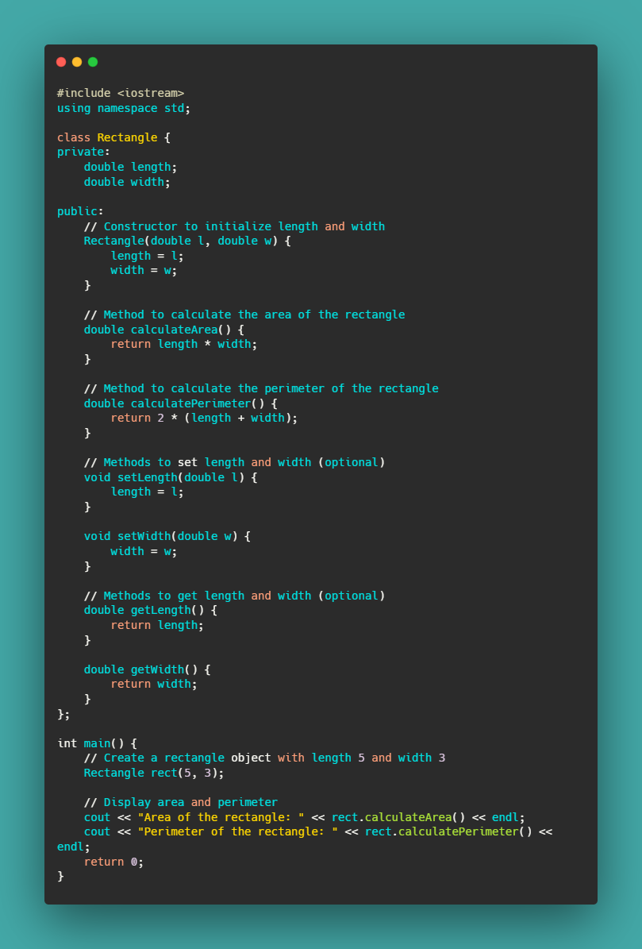
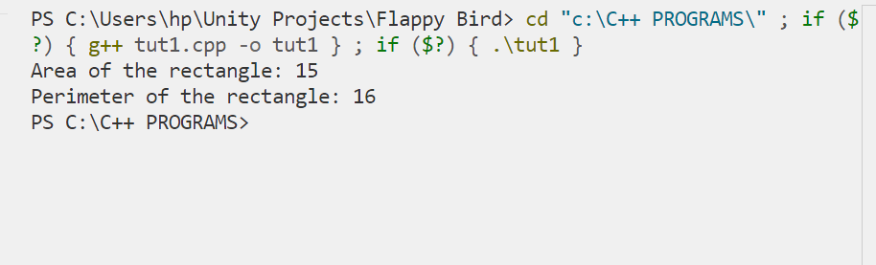
Question2: Create a class Circle with attribute radius. Implement methods to calculate the area and circumference of the circle.
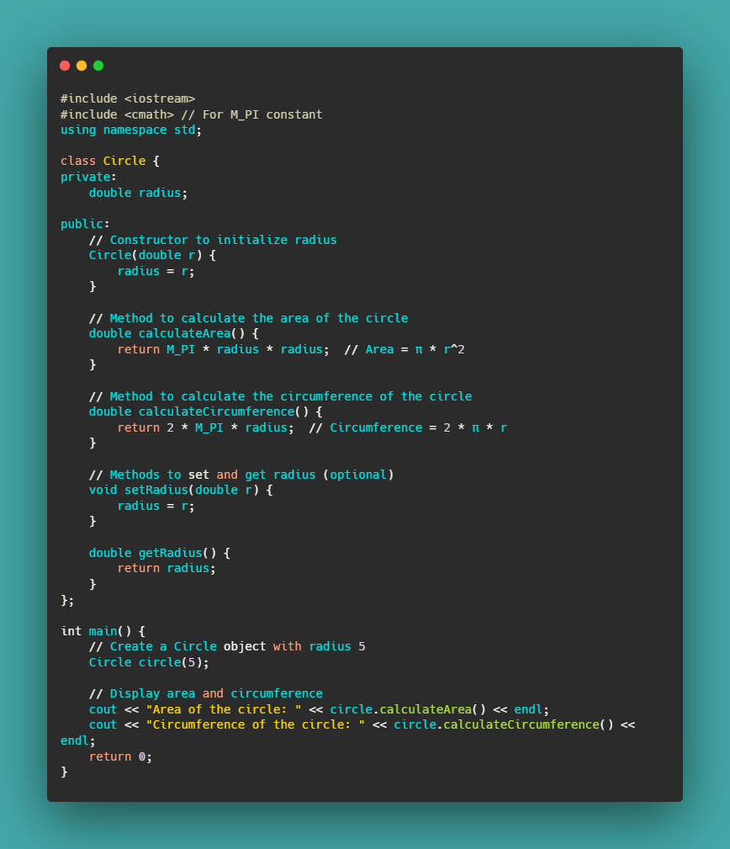
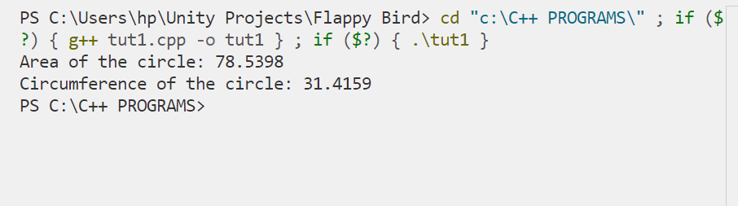

Question3: Create a class Employee with attributes name and salary. Implement a method to display the details of the employee.
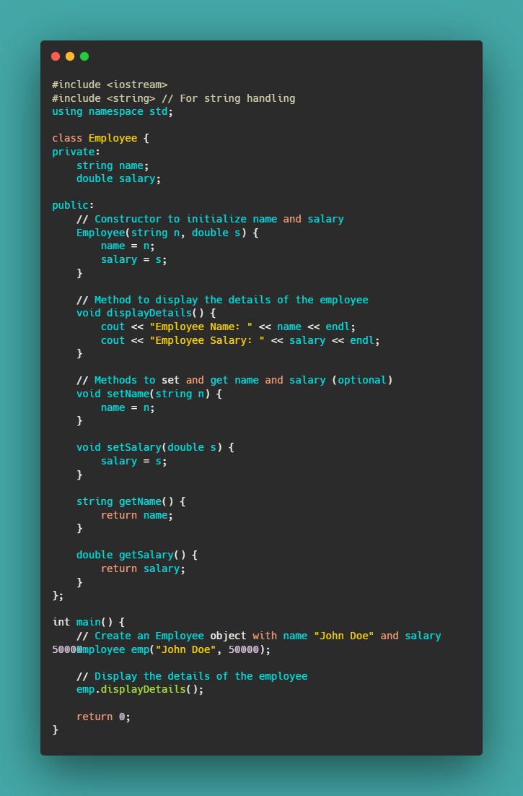
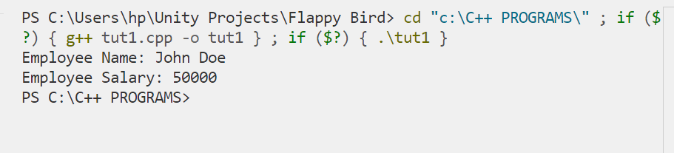

Question4: Create a class BankAccount with attributes accountNumber, accountHolder, and balance. Implement methods to deposit and withdraw money from the account.
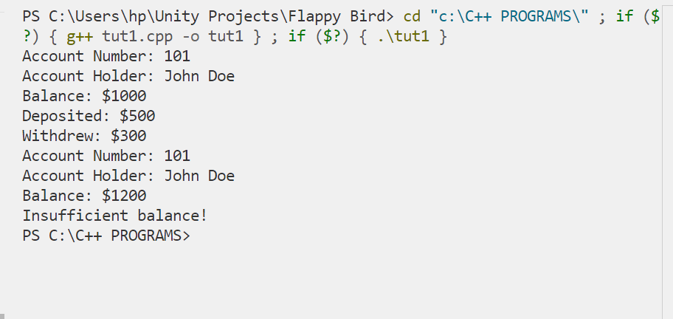
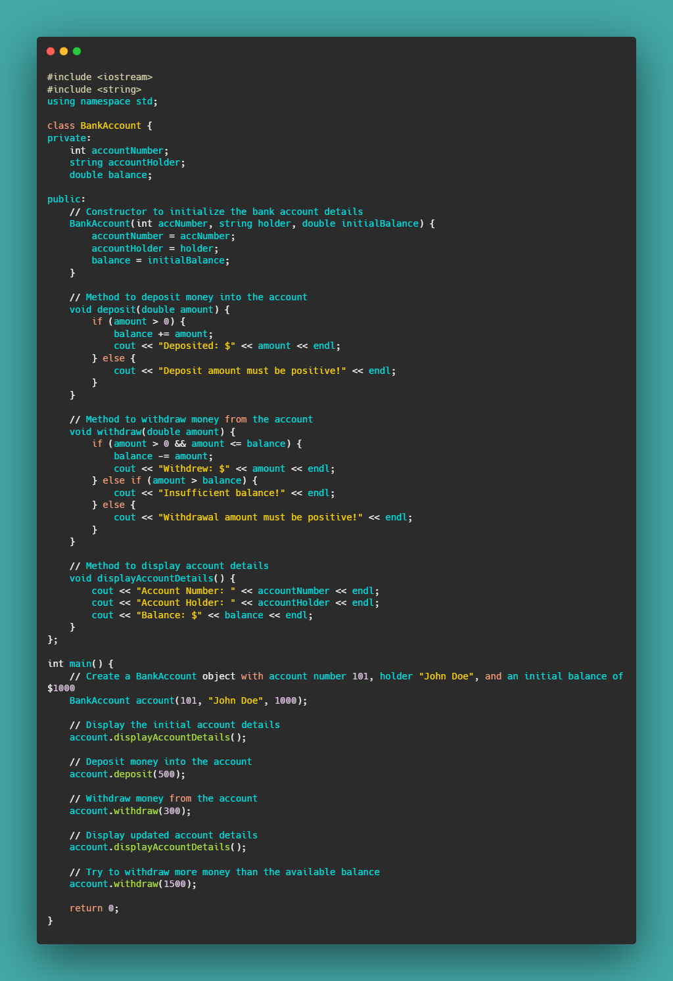
Question5: Create a class Car with attributes brand, model, and year. Implement a method to display the details of the car.
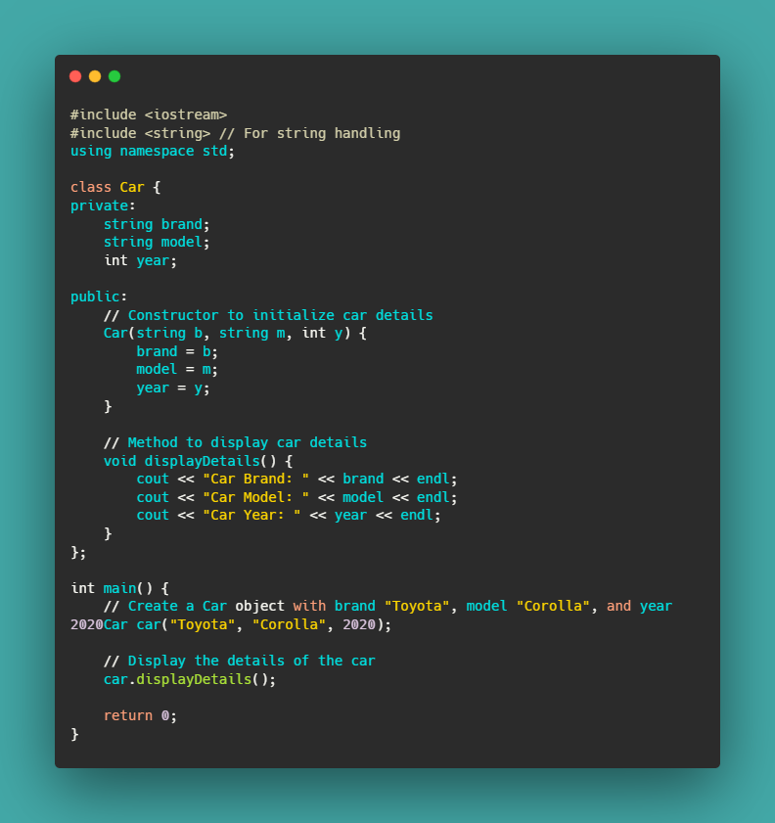
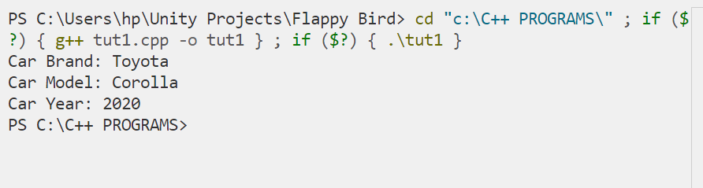
Question6: Create a class Fraction with attributes numerator and denominator. Implement a method to simplify the fraction.
